Create Your Own Tooltip

Let’s redesign our pop up captions from earlier. This page only has the picture of the whale and the text describing it.

The goal is to get the text to appear to the right of the picture, centered vertically, when the user hovers over the picture, like this:

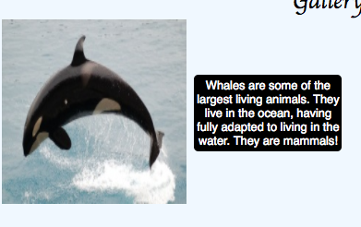

### Your Task

## Step One

Click “See HTML in new window” under the “Run Code” button.

Use the inspector to inspect what will be the tooltip (the black box of text).

Find the Styles tab.

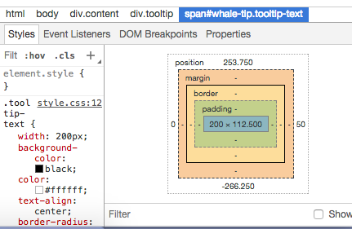

Try entering values for left and top until you can position the text like it is in the picture above, to the right of the image and centered with the image.

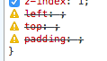

To enter text, double click on the attribute name and hit tab. This will take you to the input box where you can put in a value. Once you get it, make sure to add those values to your code!

## Step Two

If you look in the Styles tab, you will see a box that shows you what the padding and margins of the text is.

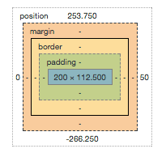

Try entering different values for the padding until you find one that makes the text easy to read because it’s not squished against the border, something between 5 and 15 pixels.

## Finishing Touches

Now, add the visibility attribute to the CSS rules .tooltip:hover .tooltip-text and .tooltip-text such that when the page first loads, the text is hidden and only shows up when the cursor hovers over the image.